**ECE 48800 Final Submission Check List**

**Project Title:**  _____________________________________________________

**Project Sponsor: Name:** _____________________________**email**:____________________ ________________________

**Each group member’s credit for this project:**

Name: ________________ credit: ___% Member’s Signature:__________________

Name: ________________ credit: ___% Member’s Signature: __________________

Name: ________________ credit: ___% Member’s Signature: __________________

Name: ________________ credit: ___% Member’s Signature: __________________

Name: ________________ credit: ___% Member’s Signature: __________________

1. **Two identical paper folders with pockets that each folder contains**

Yes ___ The folder cover with the course number, project name, names and

e-mail of group members, the sponsor’s name, phone number, and e-mail

Yes ___ The paper copy of the final report

Yes ___ This Final Submission Check List page on the first page of the report

Yes ___ A flash drive that stores all items generated in the course the course (all written reports,

software, notebook, references, manuals, schematics, PCB design files, 5 minutes hardware/software/design demonstration video, etc., except hardware).

**Two copies of folders must be submitted**

Yes ___ Two identical folders (one for sponsor and one for course instructor) submitted

1. **Copy all files in the flash drive to Canvas in a folder called ProjectName-Final-Folder-Date**

Yes ___

**Submission Date**:_______________________________________________

**MEE Agricultural Robot**

**Final Project Report**

ECE 48800 Spring 2021

**Sponsors**

*Department of Mechanical Engineering*

*Indiana University-Purdue University Indianapolis*

**Sohel Anwar** - soanwar@iupui.edu (317) 274-7640

*Computer and Electrical Engineering*

*Indiana University-Purdue University Indianapolis*

**Seemein Shayesteh** - shayests@iupui.edu (317) 278-6211

**Team Members**

**Austin Van Haitsma -** alvanhai@iu.edu

**John Baker -** johjbake@iu.edu

**Parth Patel** - pakpatel@iu.edu

**Ryan Knight** - ryanknig@iu.edu

**Trevor Baxter -** trevbaxt@iu.edu

## 

**04/28/2021**

**Table of Contents**

Project Design Introduction **5**

Project Motivation **6**

Project Background **6**

Stakeholders **9**

Project Requirements **10**

Standard Requirements 11

Constraints 11

Safety Requirements 11

Other Requirements 12

Schedule Requirements 12

Environmental Requirements 12

Potential Problems and Bottlenecks 12

Literature Review **14**

Test Plan Overview **14**

Hardware Test Plan **15**

Software Test Plan **16**

Design Options **17**

Navigation Subsystem 17

Location-Tracking Component Options 17

Location-Tracking Component Summary 18

Speed-Sensing Component Options 20

Speed-Sensing Component Summary 21

Navigation Subsystem Requirements 22

Navigation Design Challenges 23

Navigation Design Summary 23

Risks and Opportunities **24**

Project Design Conclusions **25**

Project Plan **25**

Design Process **26**

Implementation Details **27**

Network and RTK System Connections 28

Analysis and Result **30**

Problems and Troubleshooting **31**

Bill of Materials **34**

Lessons Learned **37**

Austin Van Haitsma 37

John Baker 38

Parth Patel 39

Ryan Knight 40

Trevor Baxter 40

Future Work **41**

Conclusions **42**

Reference Cited 43

**List of Figures**

Complete System Block Diagram 8

Navigation System Block Diagram 8

System Design Options Diagram 9

Verification Cross Reference Matrix 13

Pugh Matrix for GPS Component 18

Pugh Matrix for Speed Sensor Component 21

Project Timeline 26

Tinkerforge Inertial Measurement Unit (IMU) 27

Network and RTK System Connections 28

Ubiquiti AMO-5G10 Antenna 29

RTK Base Station During Testing 31

Oscilloscope Output from Speed Wire 32

**List of Tables**

Pros and Cons for GPS Component 19

Pros and Cons for Speed Sensor Component 22

**List of Abbreviations**

**Abbreviation Meaning Page**

AgBot Agriculture Robot 4

RTK Real Time Kinematic 4

GPS Global Positioning System 5

IEEE Institute of Electrical and

Electronics Engineers 11

BIOS Basic Input/Output System 29

SATA Serial Advanced Technology Attachment 29

ROS Robot Operating System 23

UTV Utility Terrain Vehicle 25

IMU Inertial Measurement Unit 25

### 

### 

### 

### 

### Project Design Introduction

Our group shall tackle the Agricultural Robot project which involves designing a new system that monitors speed from the physical device. The secondary system that our group will be optimizing is the navigation system, focusing on Real-Time Kinematic positioning navigation. Further enhancements with RTK positioning navigation should improve the quality of the AgBot navigation and speed control.

### Project Motivation

Our group is tasked with optimizing certain subsystems on the Agricultural Robot or AgBot for short. Our group will be upgrading the pre-existing autonomous navigation system, which means the AgBot operates on its own without the aid of a human and implementing a new way to capture speed data from the Yamaha Wolverine Side by Side. In its current state, the AgBot works in manual mode and our group is in charge of implementing an autonomous mode. These two systems will improve operating efficiency and lower operating costs for agricultural research and implementation. Our group will be specifically working on the RTK global positioning system. Our group shall also implement a way to extract the speed of the bot so it can be used by the other subsystems. These two optimized systems will supplement the pre-existing systems from previous efforts moving forward.

Our group’s contribution may be implemented in the Agricultural Bot Challenge Weed & Feed Competition Spring 2021. The IUPUI Agricultural Robot teams have placed second in 2019, so our group hopes to learn from prior mistakes while utilizing emerging technology. Our group's efforts may bring the first-place trophy to IUPUI for the very first time.

### 

### Project Background

We will be optimizing, upgrading, and manufacturing systems on the agricultural robot, or AgBot for short. The AgBot will be able to autonomously navigate a field equipped with an on-board weed and feed system. Our group plans on entering our robot into the AgBot Challenge Weed & Feed Competition Spring 2021, where the objective is to challenge teams with new ideas on creating a machine capable of navigating a field based on GPS as well as numerous other tasks. This was achieved with several iterations of systems design and through the incorporation of rigorous systems integration techniques, all while maintaining compatibility with one another and ensuring the vehicle is operational and ready for the competition. Our group is tasked with designing a new GPS system for the AgBot. Previous years have had some success in navigating the field, however, the margin of error was too large for manufacturing. Our goal this year is to reduce navigation error from 3-4 meters accuracy which is done with a traditional GPS Sensor down to 4-6 centimeters accuracy using Real-time Kinematic satellite navigation. Upon completion of the upgrading navigation system, our team shall address the speed recognition and display for the 2016 Yamaha Wolverine R-spec EPS Side-by-Side. Our group shall create a new display, previous attempts have been found to be faulty and inoperable.

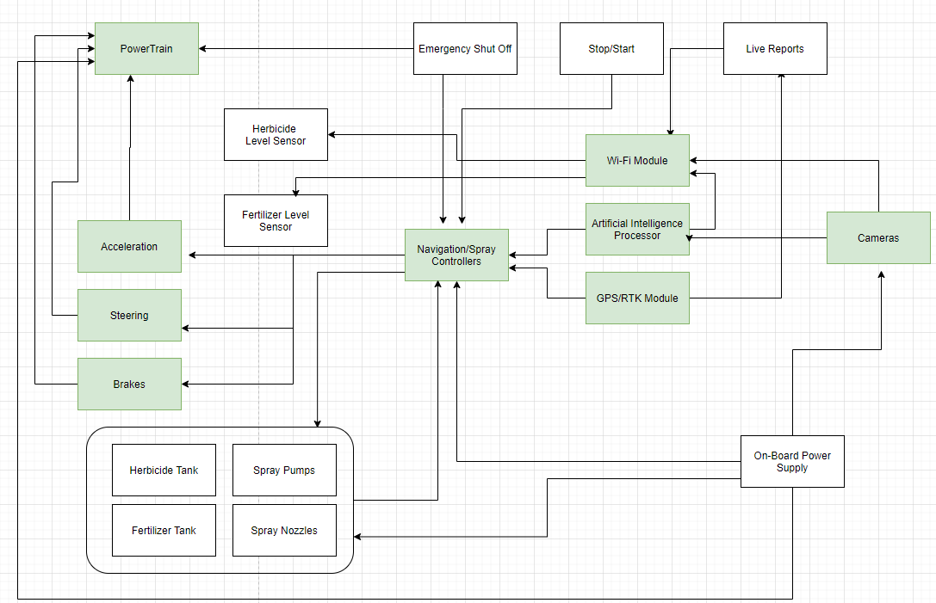

*Figure #1 - Complete System Block Diagram*

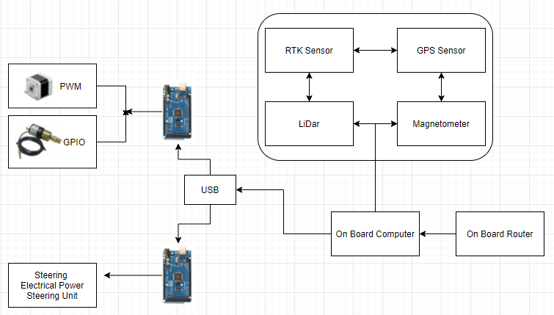

*Figure #2: Navigation Subsystem Design Hardware*

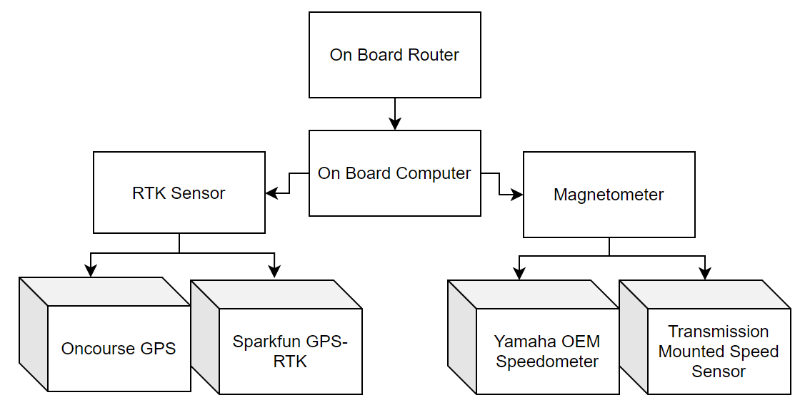

*Figure #3: Updated Navigation Subsystem Design Hardware*

**Figure 1**: Describes the entire AgBot system and subsystems from previous iterations.

**Figure 2**: Describes the subsystems that AgBot Group 1 S2021 will be addressing.

**Figure 3**: Describes the actual block diagram that we have expanded on.

### 

### Stakeholders

This project is sponsored primarily by the Electrical and Computer Engineering Department for the purpose of participating in the Weed and Feed competition in Rockville, IN held during May 2021. The professors that are advising the project include Dr. Seemein Shayesteh and Dr. Sohel Anwar.

### 

### 

### Project Requirements

**Technical Requirements**

1. Autonomously maneuver two or four 500-ft rows at a time and autonomously turn at each end.

1. The AgBot shall make two 500-ft passes on Silty clay

a loam with conventional tillage (sod if too wet for tilled

soil)

1. The vehicle shall be operated in two modes: manually and

autonomous

1. The vehicle shall start/stop remotely via a user interface from

the base station

1. The vehicle shall maintain a straight line

i. RTK GPS technology shall be considered

ii. The vehicle shall detect obstacles on its path

2. Real-time observation methods shall be transmitted back to the base station

1. AgBot shall report information to the base station via Wi-Fi
2. Movement of the vehicle shall be monitored from the base station

i. Live video stream shall be transmitted to the base station

1. Plant recognition results shall be communicated to the base station

3. Electromagnetic interference shall be minimized, RTK, GPS, WIFI

#### 

#### Standard Requirements

1. Wi-Fi connection between AgBot and base station shall meet IEEE 802.11 requirement
2. Artificial Intelligence system shall adhere to the IEEE Global Initiative for Ethical Considerations in Artificial Intelligence and Autonomous Systems
3. RTK system shall adhere to IEEE 802.22 standards and RTCM 10402.3

#### Constraints

1. AgBot shall operate in rows 30-inch wide.
2. AgBot shall turn within a radius of 60 feet at end of rows.
3. Plants and Weeds have a height of 6 – 12 Inches.
4. Terrain conditions: Silty clay loam with conventional tillage (sod if too wet for tilled soil).

#### Safety Requirements

1. AgBot shall have an emergency kill switch on both the physical bot and the remote control.
2. AgBot shall pause operations when obstacles are detected such as Humans and animals.
3. Chemical spray-system shall only spray at target plants.
4. In case of RTK disconnection, AgBot shall fall back on standard GPS.
5. If standard GPS goes down, AgBot shall stop all operations.

#### 

#### Other Requirements

1. All software used shall be licensed according to intellectual property standards
2. Artificial Intelligence system shall adhere to the IEEE Code of Ethics

#### Schedule Requirements

1. Requirement Document shall be due on 10/2/20
2. Design Options Document shall be due on 10/23/20
3. Final Report Document shall be due on 12/4/20
4. Project Demonstration shall be due on 3/26/21
5. Project Report shall be due on 3/26/21
6. Final Project Report shall be due on 4/30/21

#### Environmental Requirements

1. AgBot and components shall withstand the shock and vibrations from the ground.
2. AgBot shall function in temperatures from 0F to 150F.

#### Potential Problems and Bottlenecks

1. GPS - Real-time Kinematic Positioning System (RTK)
   1. Potential Solution: The current version of the AgBot uses a GPS signal and has components required to use RTK but speed data is missing so RTK cannot be used without getting a speed value.
2. Speed Sensor - Vehicle speed information needs to be sent to the main computer.
   1. Potential Solution: Our current plan is to try and tap into the current speed data with the technology provided by our sponsor and the previous group, but if our group cannot then our group is actively looking for sensors that can be used in case our group is not able to tap into the speed data of the AgBot.
3. Testing - adequate testing area required under suitable weather conditions
   1. Potential Solution: A possible solution is to communicate with our sponsor and find a field that is large enough to test on.
4. Other subsystem failure - while testing functionality of AgBot other subsystems do not work as intended
   1. Potential Solution: Test each subsystem before implementing speed sensor and navigation systems.

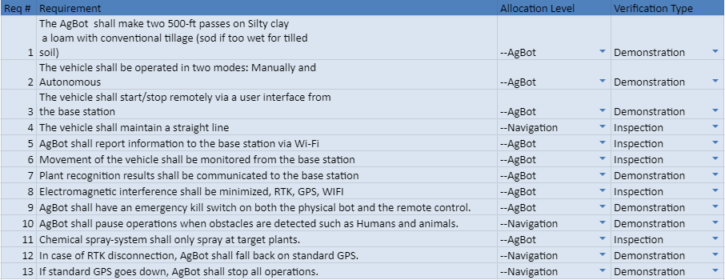

*Figure #4: Verification Cross Reference Matrix*

### Literature Review

From our research, we discovered how beneficial ROS was. After searching more about ROS, our group was able to learn about how ROS was used to control our AgBot. The debate for the operating system in the community is mainly about safety of the Robot. With the autonomous feature, the community has noticed how the robot must choose between self sacrifice and protecting others in some rare situations. This will be a constant debate as the ethics about what is right or wrong is a complete gray area that is situational based. This makes it more difficult for programmers to think of every situation and program accordingly.

### Test Plan Overview

After discussing a test plan with our sponsor, our team plans to get our sections of the AgBot working before our group formally tests the entire AgBot system. Currently, the AgBot would have to be moved out from the workshop to be tested and there are no fields nearby. This means that our group needs to test after we are confident in our implementation. Our sponsor informed us that our group is able to move the AgBot to the testing location, but it will take time to get it out of its current area so our group will only be able to move it when absolutely necessary.

Each component of the subsystems mentioned above had to be tested individually before being integrated into the larger system. Also, before integrating the new components, the existing subsystems had to be checked to ensure that they were fully functional.

### Hardware Test Plan

For our hardware testing, our group was informed all hardware was currently functioning. For our plan to test this, we have found an open parking lot where we could take the bot. This allows us to get the bot in the open and have more space to check and make sure all mechanical components are working properly.When testing the existing hardware components, we began by testing the electronic components to make sure they all were properly receiving power and dispensing it to other surrounding peripherals. This testing was split into two main phases: testing the PC’s functional integrity and testing the UTV.

For PC testing, we began by plugging in the onboard PC to a wall outlet inside the lab and booting it up to make sure it was communicating successfully with all of the other components. If the PC failed to communicate with a certain component, it was inspected further individually to ensure functionality. The provided RTK module had this issue, so naturally we looked into the issue. After further testing, it was discovered that the RTK module no longer ran on battery power and had to be directly connected to power in order for it to communicate properly with the rest of the system.

Once the PC successfully communicated with all of the components, we went ahead and began to test the UTV individually. This testing included checking the voltage of the battery, checking the fuel levels, and making sure the UTV was able to move in all directions. Voltage of the battery was measured and the battery was replaced if it did not supply the correct voltage. The fuel was replaced since the AgBot has seen limited use within the past several years before we began testing . The AgBot was driven around a parking lot multiple times to validate the functionality of its manual mode.

### Software Test Plan

For our software testing, our group was able to connect the bot online and power up the computer through an outlet. This allows us to take a look at all the files on the PC and troubleshoot different codes for different systems. Our plan after further revision of the software is to get a simulation software running to simulate the bot navigating with our current system. This should allow us to check and see if the AgBot is prepared to be fully autonomous before we take it out to the parking lot.

In order to test the software, the existing software had to be understood before making any additions. Before any software was tested or changed, a backup of all the files was made on an external harddrive in case any changes needed to be reverted. Then after learning ROS’ syntax and architecture, files were examined and parsed by their functionality. Each file was examined line by line in order to verify that the file would function as intended. Then the file would run with the AgBot lifted up by jacks in order to avoid any collisions. During this testing, there was always a group member close to the kill switch if testing needed to be stopped abruptly due to a file not working as intended.

The killswitch system was tested first in order to properly test the rest of the software. Once the killswitch system was verified, the basic remote control functions were tested. These functions included controlling the speed and steering angle with the keyboard. This testing ensured that the autonomous driving software would use the correct commands when traversing autonomously. After this functionality was verified using a testing script titled ‘Test2,’ the RTK subsystem was tested. This testing was done by first connecting the RTK module to power and then connecting to the same network as the sensor on the AgBot. Our team used a laptop to connect to the RTK module and it served as a base station that would relay all relevant kinematic information in real time. The RTK sensor on the AgBot was initially moved by hand to verify basic functionality, then was tested for accuracy by driving the AgBot in a parking lot while observing the changes to the RTK data on the base station.

### 

### Design Options

#### Navigation Subsystem

The navigation subsystem will be responsible for autonomously controlling the drive, brake, and steering mechanisms of the AgBot. This subsystem is essentially the main driver of the vehicle in its autonomous mode. This subsystem consists of two important components; the GPS location-tracking component and the speed-sensing component.

#### Location-Tracking Component Options

The AgBot will be equipped with a GPS to enable accurate location-tracking capabilities that will further enhance the performance and reliability of the vehicle’s autonomous systems. The vehicle currently has a GPS installed on the exterior of the vehicle, however, this system is not currently capable of making the vehicle fully autonomous. To fix this, our group has explored two options; the first being that our group utilizes the current hardware and explores ways to integrate it using the software. The potential downside to using the existing GPS system include potential software issues, such as the requirement to learn a new programming language, and unknown device performance. Some advantages of using the existing GPS system include lower cost, no wait time for equipment to be delivered, and little to no additional installation is required.

The second option our group explored involves buying a new GPS system and completely removing the existing system. The drawback of buying a new GPS system includes a high-cost, long delivery time, and unanticipated compatibility issues. Buying a new GPS system does have advantages, such as the potential for easier vehicle integration and increased capabilities.

#### Location-Tracking Component Summary

Based on these criteria, our group decided to configure the pre-existing GPS system rather than purchasing another one. The cost-effectiveness and time-efficiency of using the existing component far outweigh the knowledge barrier to implement the hardware. The alternative is far too inefficient and expensive to be practical.

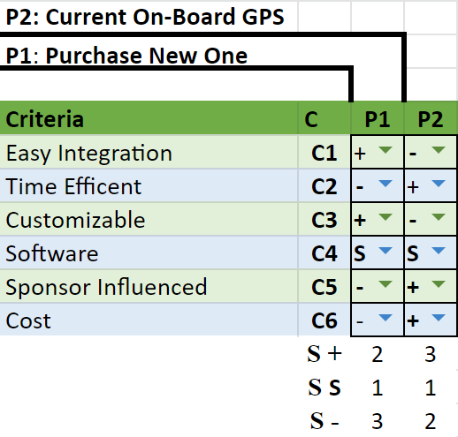

*Figure #5: Pugh Matrix for GPS Component*

|  |  |
| --- | --- |
| Configure Current On-Board GPS | Purchase a New GPS  (Sparkfun GPS-RTK2-ZED-F9P) |
| Pros:   * Cost-effective * Time-Efficient * No Additional Installation * Previous team members as a knowledge resource | Pros:   * Easy Integration * Customizable Capabilities * RTK - 20Hz * Concurrent reception of GPS, GLONASS, Galileo, and BeiDou |
| Cons:   * Software Issues * Knowledge Barrier * Current components may be faulty with low chance of finding issues in time to remediate * Testing On-Board components have to wait until Spring | Cons:   * Costly * Time-Inefficient * Potential Incompatibility * A minimal amount of documentation * Support and analysis software is minimal as well |

*Table #1: Pros and Cons for GPS Component*

#### Speed-Sensing Component Options

The AgBot’s Speed-Sensing Component will measure the vehicle's speed and relay this information so that it can be sent back to the base station. There are a couple of different options available, the first of which is isolating data from the existing onboard speed sensor. This will involve tapping into the wiring on the Yamaha Wolverine and interpreting the voltages into speed using a microprocessor. Some pros of this option include it being the most cost-effective solution since not much hardware is required. It also has less moving parts to worry about, meaning that it is more reliable than any other option. One downside to this option is that there is a higher risk of breaking the on-board hardware that already works. Since our group is messing with the vehicle wiring, there is a risk that our group could interfere with or short out the vehicle wiring, which could result in a vehicle malfunction. Another downside is that it requires a much more in-depth understanding of the vehicle, which would cost us time.

Another design option available to us is creating a new speed sensor. One advantage of this is that there is less risk of breaking the parts that have already been created for the AgBot since our group will be creating a new part and plugging it in. Another advantage is that our group will have an intimate understanding of the design, resulting in less time spent figuring out how it works. It can also be more versatile since our group has control of the specs and design of the sensor. There are several downsides to this option, including it being the most costly option. Designing a sensor from scratch will require a lot of time designing the component and money to assemble one that will not malfunction. There is also the possibility that it will be incompatible with the current system. This design option also will not be as durable as the built-in sensor, which could result in component failure.

#### Speed-Sensing Component Summary

For this component, our group will prioritize tapping into the vehicle’s speed sensor since it is more cost-effective and durable when compared to purchasing a new sensor. If our group is unable to tap into the sensor or it proves too difficult to understand the readings, our group will resort to design option two and purchase a new sensor and use it to determine the speed of the vehicle.

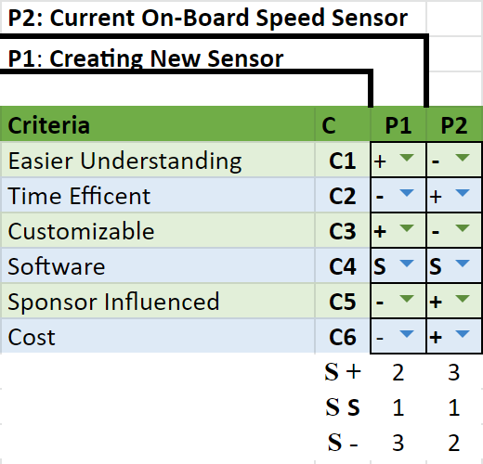

*Figure #6: Pugh Matrix for Speed Sensor Component*

|  |  |
| --- | --- |
| Use On-Board Sensor | Creating a New Sensor |
| Pros:   * Cost-effective * Less moving parts * Durable | Pros:   * Less risk of breaking subsystems * Versatile * A deeper understanding of sensor |
| Cons:   * More risk of breaking sensor during setup * Requires in-depth knowledge of system | Cons:   * Costly * Potential Incompatibility * Prone to failure * $66 sensor |

*Table #2: Pros and Cons for Speed Sensor Component*

#### Navigation Subsystem Requirements

The vehicle is required to autonomously maneuver two or four 500-ft rows at a time and autonomously turn at each end. For this purpose, the navigation shall keep the vehicle running on a straight line as well as performing radius restricted turns at the end of rows. To meet the safety requirements, the navigation system shall shut off if the navigation signal is lost or the emergency stopping system is executed.

#### Navigation Design Challenges

The navigation subsystem of our agricultural robot is dependent on the global positioning system that is relayed from the RTK sensors. The AgBot should traverse to each waypoint on the path supplied from the base station. The base station is a fixed point on the agricultural field that transmits data to and from the agricultural robot.

A secondary design challenge is a physical terrain that the robot will need to travel across. Our system will need to utilize the RTK signal for extra accuracy to supplement any derivation from the intended path.

Our team recognized that the vibrations caused by traversing the field may interfere with other subsystems on our robot. Our team feels that a software approach can be implemented to keep speed sensors accurate should the latter be altered by vibrations.

#### Navigation Design Summary

Our group’s updated navigation subsystem is responsible for guiding the vehicle between the rows and while turning at the end of each row. The use of an autopilot unit in conjunction with Mission Planner software can simplify the implementation of the intended module but limits the possibilities to handle exceptions such as GPS signal loss or signal prioritization (RTK as primary source followed by GPS).

Our team researched command log histories in order to reveal the boot sequence needed to start the automated driving sequence. The following sequence of steps details the boot sequence for the automated driving sequence:

1. Roscore needs to be launched in a linux terminal.
2. “Roslaunch tinkerforge-sensorstinkerforge-sensors.launch” executed in second terminal
3. In a third terminal: “Rostopic echo tfsensors/imul”
4. Then “Rosclean”
5. Finally “Rosrun ackermann_drive_teleop keyop.py”

### Risks and Opportunities

Our group presents a breakdown of the Risks and Opportunities organized by the subsystem.

**Risk:**

* If any of the navigation design choices do not function with the rest of the design options (20% probability), then the design choices will have to be changed.
* When purchasing new components we risk damage when shipping and time delays (10% probability).
* Testing components in the field may damage critical components when the AgBot is maneuvering over rough terrain (10% probability).

**Mitigation:**

* Other navigation options will need to be researched, as well as total system compatibility, which will need to be ensured prior to implementation.
* Utilizing pre-existing components should minimize ordering risks as well as decreasing total unit costs.
* Our group should address testing sites that simulate an agricultural scenario within a downtown scenario.

### Project Design Conclusions

The subsystem choices include the different viable options our group has researched. Our team used a mixture of pros and cons analysis and trade studies, that best suit the requirements for our different subsystems. Our group has found the possible risks associated with these options and included them in our report. Our group’s next steps for our project include planning out an interactive design for these subsystems for interfaces between the subsystems. Our group will move onto the concept prototyping stage once our final design is in place.

### Project Plan

With our design options determined at this point, we began to form a plan on how to implement these design options into the AGBot’s design. Our plan going into the implementation was to first determine how the ROS files on the AGBot were implemented on the on-board computer and determine each one’s function. From there, we would get a clear picture of how the navigation and RTK GPS subsystems were related to each other. This would give us a better understanding of these subsystems and might even offer us a clear way to diagnose the issues present in them. Next, we shall move into focusing on isolating the speed data. Our bot is currently accelerating too quickly, and we hope with some more testing in an open area we will figure out the issue.

*Figure #7: Project Timeline*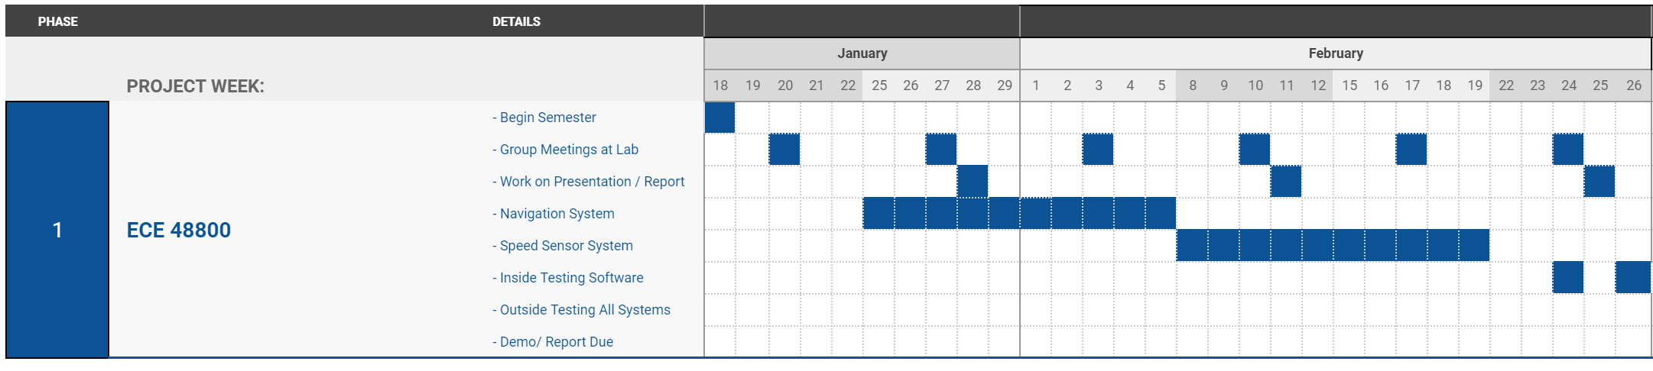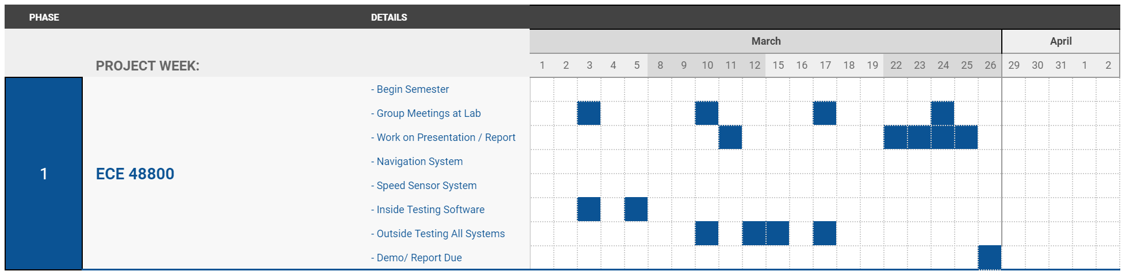

### Design Process

For our groups design process, we were very limited in this section since our project has been passed down from many groups. The options outlined above in our design options section were a backup plan in case any of the provided materials did not function as expected. Using our onboard sensors, we were able to check and get accurate readings for both position and velocity. This was very useful as it proved that our selected design option would be enough for us to complete the project.

### Implementation Details

This section describes the approach taken after the part selection was finalized. The onboard PC is used to communicate between the multiple arduinos, IMU, RTK, and the UTV. Each Arduino controls a specific aspect of the system. One controls the acceleration and braking, another controls the turning, and the last one controls data received by the various sensors on the AgBot. The Tinkerforge IMU unit measures 9 degrees of freedom and can compute quaternions, linear acceleration, gravity vector, and independent heading, roll, and pitch angles. The Tinkerforge IMU data is designed to be converted into a format that can be used by the ROS code.

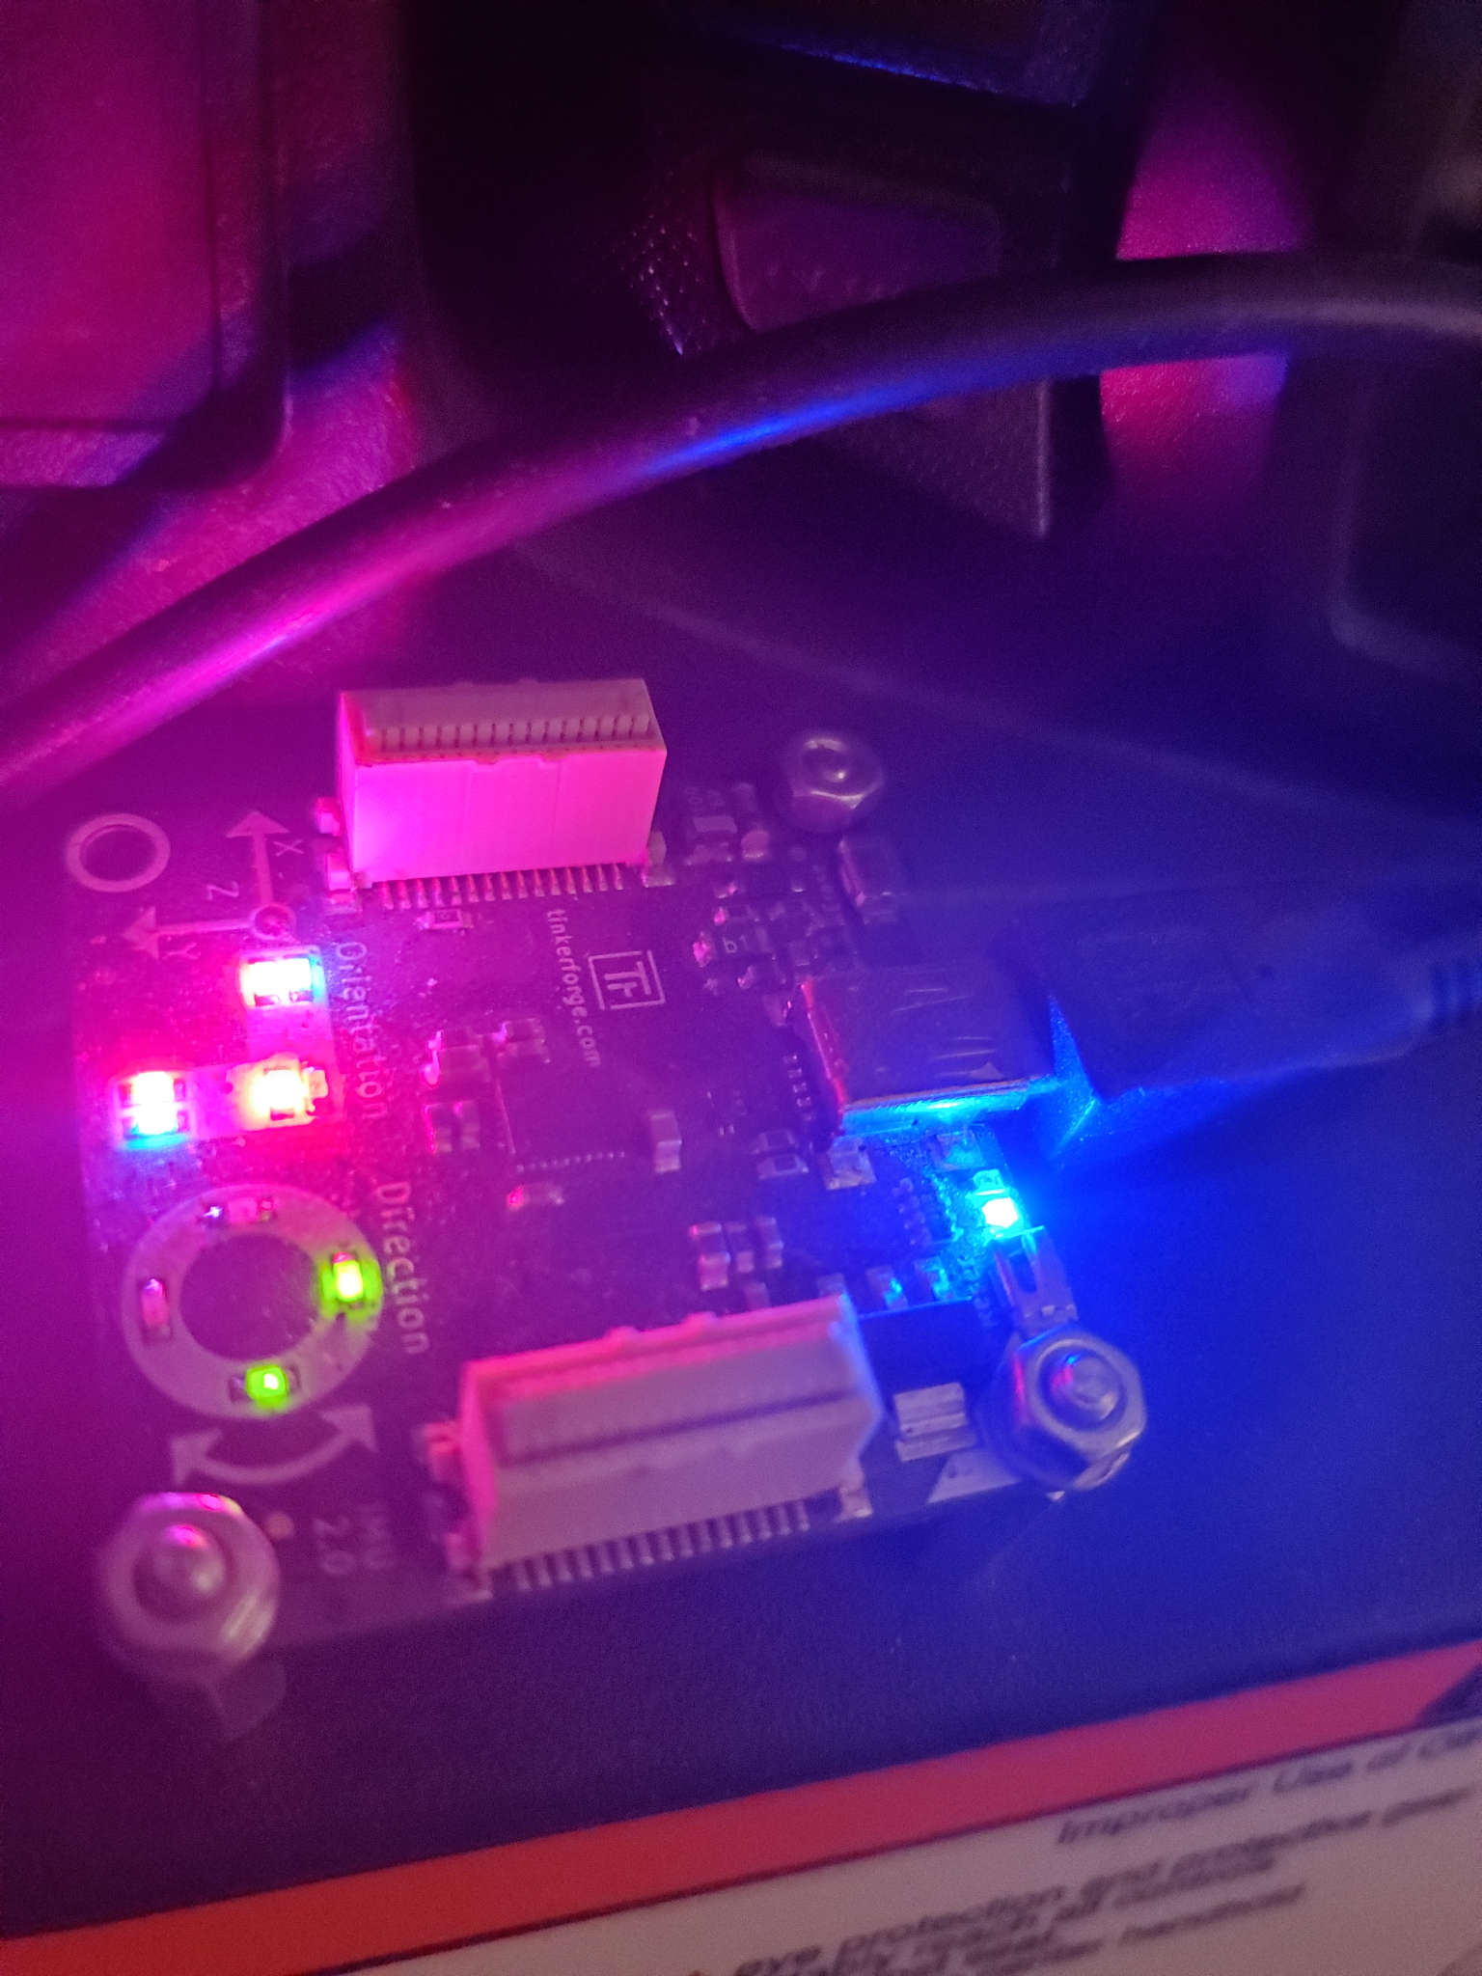

*Figure #8: Tinkerforge Inertial Measurement Unit (IMU)*

#### Network and RTK System Connections

*Figure #9: Network and RTK System Connections*

The IP addresses for some of the networking equipment are listed below:

* Ubiquiti AMO-5G10 Antenna (Base Station): 192.168.1.159
* Ubiquiti AMO-5G10 Antenna (Base Station): 192.168.1.161
* Base Station PC: 192.168.1.x - Varies
* AgBot’s Linksys Wi-Fi Router: 192.168.1.1
* EMLID Reach RS+ (Base Station RTK): 192.168.1.128
* AgBot On-Board PC: 192.168.1.119
* EMLID Reach (AgBot RTK Module): Can be found by opening a terminal on the AgBot and typing the following command: <arp -a>

The above figure shows the design of the network connections between the AgBot, RTK modules, Base Station PC, and other network components. As stated previously, the base station PC needs to receive the RTK systems data. To accomplish this, the base station computer can be connected in three ways:

* Wireless Connection to AgBot’s Linksys Router
* Wired Connection to the Ubiquiti AMO-5G10 Base Station Antenna
* Wired or Wireless Connection to the Main Access Point or Router

In addition, the base station RTK can be connected either wirelessly to the AgBot’s on-board Linksys router or wirelessly to the main access point (or router) that is connected to the Ubiquiti AMO-5G10 base station antenna. There are options available from the RTK manufacturer that allow the base station RTK to connect over a physical local area network by sharing an ethernet connection from a PC, but this functionality was not needed for testing.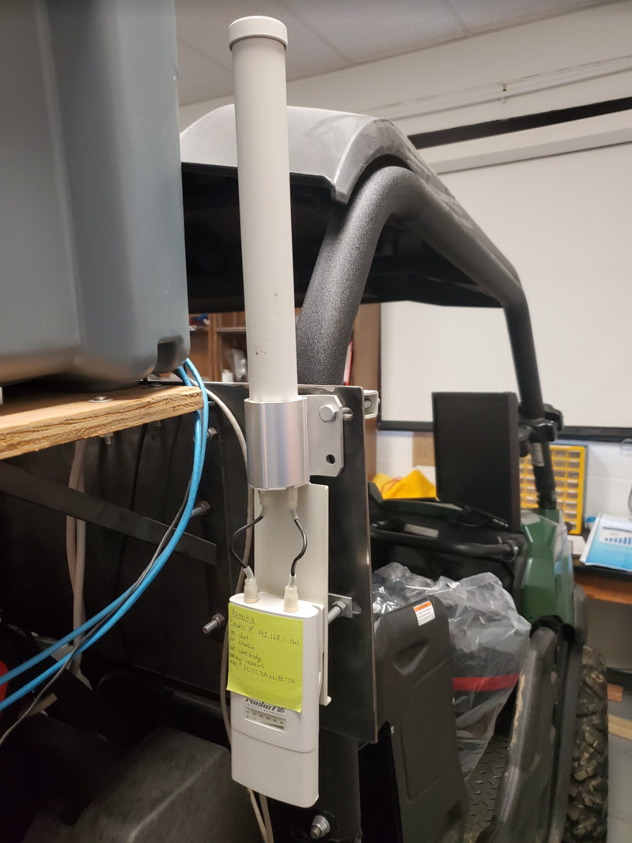

*Figure #10: Ubiquiti AMO-5G10 Antenna*

This flexibility allows the user to connect to the AgBot in different ways allowing for use in varying terrain conditions. As the Ubiquiti AMO-5G10 antennas provide long range connections, it is best to use the AMO-5G10 antenna connections when the AgBot will be utilized at distances exceeding 100-ft or whenever line-of-sight conditions are not possible with the base station PC or base station RTK. If the AgBot is operating within line-of-sight and will not exceed 100-ft from the base station RTK or base station PC, it is best to connect these systems to the AgBot’s on-board Linksys router as this decreases the number of possible link failures and greatly reduces setup time and overall system complexity.

### Analysis and Result

Once the existing subsystems were tested individually then the AgBot as a whole was tested. Due to the AgBot being in a small workspace for most of the year we were only able to test during the late phase of the semester. After moving the AgBot, we were able to integrate the RTK module and view the RTK data in real time at a base station as shown below in Figure 10. We were able to verify that the speed reading we get is the correct one and we have verified the accuracy of the RTK module. However, due to testing constraints we had limited testing with autonomous driving and navigation. We still need to tune the speed data through testing to verify the ability of the AgBot to navigate a field autonomously.

*Figure #11: RTK Base Station During Testing*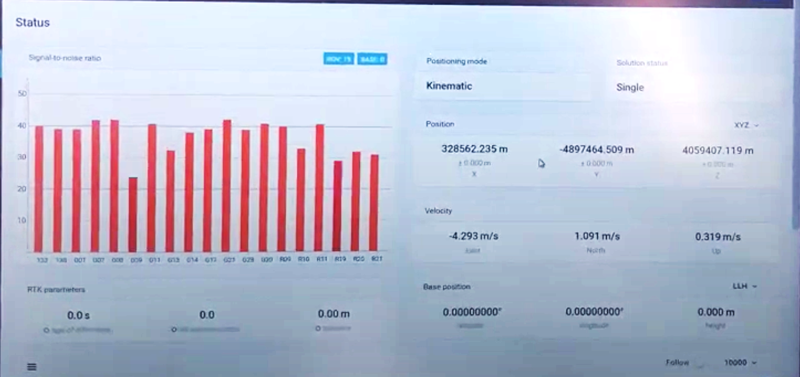

### Problems and Troubleshooting

During this implementation phase, our group encountered numerous problems regarding both the hardware and software of the AGBot. The first problem arose immediately when we began testing the AGBot, which was that the vehicle would not start. Whenever we would attempt to turn the ignition, there would be no audible or visual response from the UTV. We were not entirely sure what the issue could have been, but we did suspect that it was a dead battery. We ordered a new battery as detailed in our Bill of Materials (See next section) and used it to replace the current one, but until that arrived our group would need to jumpstart the UTV every time we needed to test it. The UTV could also only be tested for short periods of time because it was located in a small space before it could be moved for testing.

Another hardware issue that our team ran into was regarding the onboard computer. It would frequently fail to boot up whenever we would turn it on. To troubleshoot this issue, the solid-state drive was uninstalled from the onboard computer and the drive was booted from a separate computer. Booting from another computer was successful however, the Operating System did not recognize the hardware it was running on, and would therefore not allow any user to log into the system. Since that was not a viable solution, the team continued to troubleshoot the issue. This involved checking the power supply and its connections to the motherboard, unseating and reinstalling the internal graphics card and memory, and also booting into the system BIOS. Eventually, we tried booting the computer from the drive externally using a harddrive enclosure and that worked. As it turned out, the SATA cable that connects the drive to the motherboard was malfunctioning, which is why the onboard computer was not booting properly. Despite fixing the SATA cable, our group still has to spend about 20-30 minutes booting up the computer through the BIOS every time we need to use it. The cause of this issue is still unknown, but the PC does usually boot when the graphics processor or other components have been reseated/reconnected.

*Figure #12: Oscilloscope Output from Speed Wire*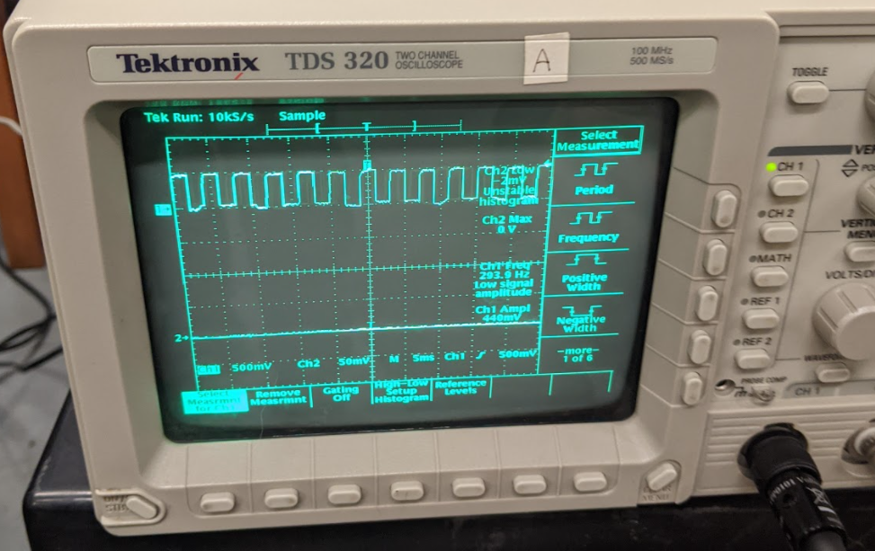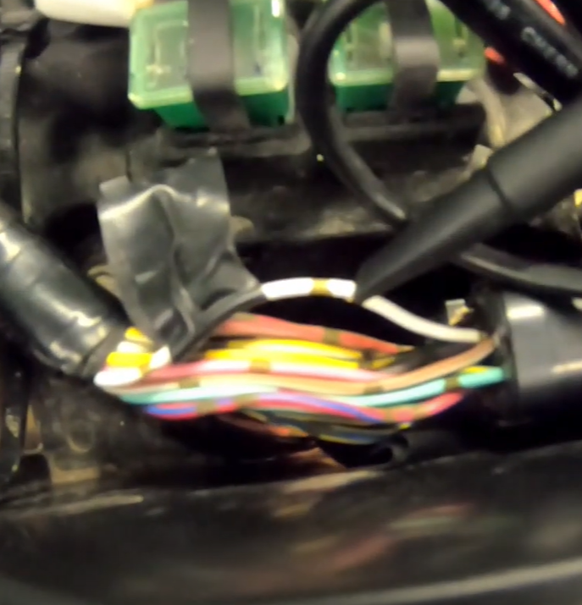

The next issue we ran into was after testing the software. We noticed that after running a testing script for autonomous driving, the mechanical system used to control the throttle and braking system was sticking causing the accelerator to have too much tension, which would cause the AgBot to accelerate past our desired speed. We were able to loosen the tension during one of our tests by turning the bearing in the other direction, however, we were unable to determine if this was a software or hardware issue. Troubleshooting this issue, we found the internal speed wire in the vehicle. We were able to troubleshoot and verify the vehicle's system is receiving the speed wave output at the correct frequency which is shown about in Figure 11.

Our biggest issue were error codes that appeared after trying to implement all of the systems together. We quickly realized we had many outdated files and copies of different files that were not essential to the project. Previous groups did not leave many comments for us to read through, and there was also no documentation on how to clean up the undesired files. This made things very difficult to figure out where our error codes were coming from as we were unsure which files were the last ones to be fully operational. After many setbacks and waiting for previous members' responses to us, we were able to meet with previous project lead Sohin and debug more errors with his help. We believe we are receiving an error for the steering and throttle PID and some covariance factors which are causing the whole system to fail.

### 

### 

### 

### 

### Bill of Materials

|  |  |  |  |  |  |
| --- | --- | --- | --- | --- | --- |
| **ITEM** | **PART NO.** | **VENDOR** | **QTY** | **COST/ UNIT** | **TOTAL** |
| **TP-Link 8-Port Gigabit Ethernet PoE 8 Port Switch** | #23912 | Monoprice | 1 | $169.99 | Provided |
| **Client-Side Wireless Nanobeam NBE-5-AC-19** | #20482 | Monoprice | 1 | $89.00 | Provided |
| **Ubiquiti Brand Access Point Router** | #19400 | Monoprice | 1 | $187.99 | Provided |
| **Arduino Mega** | 1050-1018-ND | Digikey | 5 | $38.50 | Provided |
| **Intel RealSense Camera** | 607-82635ASRCDVKHV | Mouser | 1 | $169.00 | Provided |
| **1800- Watt Portable Generator** |  | houzz.com | 1 | $167.99 | Provided |
| **12V, 7AH Rechargeable Gel Cell Battery** | #14819 BT | MPJA | 2 | $22.95 | Provided |
| **Base Station Battery Pack 5V @ 1A** | ID: 1565 | Adafruit | 1 | $24.95 | Provided |
| **Cables For Power** | WA06-00-10 | Allied | 2 | $30.25 | Provided |
| **Electric Switches For Power** | 360-3240-ND | Digikey | 2 | $3.31 | Provided |
| **Battery Charging Cable** |  | Amazon | 1 | $7.99 | Provided |
| **Hook-up Wires** | #2153705 | jameco | 1 | $15.95 | Provided |
| **Fuse Holders (ATC)** | #28879 FH | MPJA | 10 | $1.25 | Provided |
| **1 Channel Relays** | #32442 MP | MPJA | 5 | $3.95 | Provided |
| **4 Channel Relays** | #2255251 | jameco | 3 | $8.95 | Provided |
| **15 Amp Fuse** | #23616 FU | MPJA | 2 | $1.50 | Provided |
| **20 Amp Fuse** | #23617 FU | MPJA | 2 | $1.50 | Provided |
| **25 Amp Fuse** | #23618 FU | MPJA | 2 | $1.50 | Provided |
| **30 Amp Fuse** | #23619 FU | MPJA | 2 | $1.50 | Provided |
| **35 Amp Fuse** | 283-3322-ND | Digikey | 15 | $0.93 | Provided |
| **40 Amp Fuse** | 283-2833-ND | Digikey | 15 | $0.93 | Provided |
| **Arduino DC Power Adapter** | TOL-00298 | sparkfun | 5 | $5.95 | Provided |
| **Ethernet Cables** | #201822 | jameco | 3 | $2.75 | Provided |
| **Long Range RF Transmitter** | #315-MD-ND | Digikey | 1 | $27.72 | Provided |
| **Emergency Mushroom** | #34720 SW | MPJA | 1 | $8.95 | Provided |
| **PCB** | #2191488 | jameco | 10 | $3.15 | Provided |
| **Solder** | #33594 TL | MPJA | 1 | $9.95 | Provided |
| **Electrical Tape** | #19555 MI | MPJA | 1 | $0.99 | Provided |
| **USB to Micro-Usb Cables** | #34479 CB | MPJA | 1 | $4.95 | Provided |
| **SMA Connector for GPS** | ACX1568-ND | Digikey | 2 | $12.41 | Provided |
| **443 A H-Bridge** |  | Amazon | 5 | $15.50 | Provided |
| **12V Vehicle Battery** | SLIU1HP | Batteries Plus | 1 | $57.99 | Provided |
| **Total** |  |  |  | $1,519.39 | Provided |

### Lessons Learned

#### Austin Van Haitsma

Out of every course that I have taken during my college career, this senior design course was the only one to place such a large emphasis on group work. I feel that it is important for schools to prepare students for the careers that they hope to enter once they graduate and an important aspect of that is how well they can collaborate with others. My experience in this course was just that; a preparation for how to work with others to complete a project. From delegating responsibilities to scheduling meeting times, this AGBot project largely contributed to my ability to work well in a group. Not only that, this project was by far the longest team project that I ever worked on. Coordinating and meeting with the team made me more comfortable working in a group environment. That skill will definitely contribute towards my success in my future career.

Another vital skill this taught me was how to handle things when it seems like everything is going wrong at once. With how many hardware issues, software problems, mechanical malfunctions, and even remote work mandates that we ran into, we as a group were able to pull through and deliver our product despite these issues. By remaining level-headed and thinking through each problem as a team, our group can conquer almost any obstacle with enough effort. The only question you need to ask yourself and your team is how much effort is worth investing in a problem if there are other, potentially larger problems that need to be solved. If everyone were to focus solely on fixing a single problem and ignore every other problem, that would be a massive waste of time and resources that could have been spent working on other issues. Sometimes we just have to know when to let a problem go and accept that it will be the way it is.

This AGBot group project was a valuable experience for me as it taught me the lessons that I have outlined above. Understanding and applying the skills necessary to work in a group was by far my biggest takeaway and I know that it will come in handy in the future.

#### John Baker

Group projects are often the most interesting and challenging part of the year. Working with my team members has been a great experience working with different skill sets and talents that meshed together well. There were numerous times when one or two of our members were absent or were unavailable that our team members stepped up to the plate to get the job done. Our group had decided to hit the ground running in semester 1 and met in the lab after the third week of class. Our team members were eager to learn the new system, understand the technical components that made the AgBot function properly as well as reverse engineer the current subsystems that needed to be optimized. AgBot Group 1 did a great job communicating with each other what tasks and priorities needed to be revised throughout the year and we all gained lifelong friendships in the process.

The system development life cycle was a crucial part in planning our design options. Through careful requirement and system analysis we were able to design the appropriate subsystem algorithms and configurations that would go into our development, integration, and testing phases. While we were extremely careful in how we planned out our work we did have many hiccups along the way. However, our group was able to adapt and overcome these by following the requirement documentation as well as referencing our sponsor and his colleagues. There were some things that I wished were done differently for the next group. A more prepared package of instructions on how to power up the bot, implementation of software and exact component data sheets that need to be addressed would have been helpful in accomplishing our tasks. I understand that our group’s project has not been addressed in some time so that was a big roadblock that we needed to overcome.

Overall, the Agbot senior project was a great experience, working with other engineers in different fields is very important when entering the professional workspace. Truly no one works alone in our discipline and seeing our group members contribute in meaningful research while accomplishing our tasks was very rewarding. I am very proud of our group and the product that we have created.

#### Parth Patel

Working on the AgBot for the past year has taught me a lot about working as a member of a team on a bigger project. I learned the importance of team communication and relying on other team members. Throughout the year there were times when not all team members were able to meet or contribute due to schedule conflicts and it was important that we communicated with each so that the project continued to be worked on. I also learned and got experience with time management as a group. Throughout the year it was important that the project met certain deadlines. This involved learning what we were capable of doing as a team so that we could effectively plan out or meetings so that the most work was done on the project.

I also learned the importance of documentation when working on a project. The groups that worked on the project previously did not document what they did very well and that made it very difficult to work on the AgBot initially. We had to reach out to a member from a previous group and he had to help us through some of our errors, but he did not remember the exact details since it had been a few years since he worked on the project. Going forward it is important to document work so that it is easier for someone else to work on the project.

Some specific information that I learned by working on this project include learning how to code in ROS, more experience in Python, and some very basic information about networking. Throughout the year, I learned how ROS worked and how it can be used in various applications. This was important when diagnosing what the previous groups had done so we could add to the project. Since the AgBot has so many subsystems I was able to learn a little bit about all of them while we were testing each of them. All of this information will be very useful when working on any kind of project in the future.

#### Ryan Knight

Throughout the course of the project, I learned how the AgBot was initially designed and theorized as to why the previous groups went with those design decisions. However, it became apparent fairly quickly that I did not have a strong understanding of the ROS software implementation and how the ROS launch files were calling other functions or nodes. For these reasons, I wish we had reached out to previous group members earlier in the semester to see if they could help us understand their software implementation in greater detail.

While I feel the software issues were a major challenge, I did learn a lot about ROS Kinetic, Python, RTK systems, Ubuntu (and Linux in general), and the network software that is used in the Ubiquiti antennas as well as the various routers and other networking equipment. For these reasons, I am very happy with the progress our group made and the amount of knowledge that I have acquired throughout the project that I will be able to utilize when working on complex systems in the future.

#### Trevor Baxter

Our senior design project was a great learning experience in accomplishing a challenge that none of us were too familiar with. It was a great experience to plan out a project throughout a year and manage our time wisely to reach certain goals. The difficulty we experienced trying to see the AgBot in its last functioning state was nearly impossible. Although this made our project more difficult than intended, it was a great experience to work on a project multiple teams have worked on. This showed us first-hand how important documenting our own work was.

Although we did not achieve our goal of the AgBot being fully autonomous, I believe this project has improved my ability to research and learn about new systems I was not familiar with. This is going to be beneficial for all of us in our careers. Specifically, this project was great to learn about ROS, Python, and Linux. The ROS system was something completely new to me and has created a new interest for me. I am pleased with our group’s progress throughout this difficult time. With all the restrictions in place, I believe we created the most out of the situation, learned how to deal with adversity, and still accomplish a goal as a team.

### Future Work

The current state of the AgBot is close to functioning autonomously. In order to reach the goal of fully autonomous navigation the current files need to be cleaned up further and updated to work with the new version of ROS. Most of the current hardware components can also be updated to function more efficiently when doing calculations for autonomous navigation. The Arduino’s can be replaced with a Raspberry Pi or Jetson TX2. Ubuntu and ROS can both be updated with a new more powerful PC so more calculations can be done while navigating. The current version of the AgBot has been worked on over various years and by many groups of people. Hardware and software have both changed since the conception of this project. The newer version of ROS is more compatible with the goal of this project and Ubuntu has been updated to be more reliable of an operating system.

### Conclusions

The AgBot is a complex project that requires knowledge on a large number of topics. The team working on this project comes from varying backgrounds with different skills and life experiences. By working together, the skills known by each team member can be used to improve upon the previous iterations of AgBot.

The AgBot team was able to see a system that combined hardware and software. The team had to learn to use ROS and Python to work on the software that was created by previous groups for the AgBot. By working on the Yamaha Wolverine, the team was able to gain a better understanding of automotive technology. The team also gained experience working with embedded systems where multiple microcontrollers were used to connect multiple sensors that would be used to perform various tasks by the AgBot.

Our Agbot team was able to create another folder and clean up some duplicate files for a startup sequence. This allowed us to narrow down our error codes and where they were coming from. Our team worked with a previous team lead of the project as he informed us a lot of files on the computer were unnecessary and not working properly.

Overall, this project was a look at how projects are done in the workforce. Engineers work on projects that combine multiple subsystems that do various tasks and these systems must be integrated properly for the project to be successful.

#### Reference Cited

Bringing innovative and novel robotic approaches to applications for agriculture. (2019, December 17). Retrieved December 02, 2020, from https://ag.purdue.edu/aggrowbot/

Cdn.yamaha-motor.eu. 2020. [online] Available at: <https://cdn.yamaha-motor.eu/owner-manuals/Side-By-Side/PBN5F81997AE.PDF> [Accessed 2 December 2020].

Foote, T. (2009, August 17). ROS/Introduction Technical Wiki. Retrieved December 02, 2020, from <http://wiki.ros.org/>

Gatliff, B., #517276, M., Horse, S., #1502912, M., #1494987, M., #589719, M., . . . #1536405, M. (n.d.). SparkFun GPS-RTK2 Board - ZED-F9P (Qwiic). Retrieved December 02, 2020, from https://www.sparkfun.com/products/15136

Ina. (n.d.). Real Time Kinematic (RTK). Retrieved December 02, 2020, from https://www.vboxautomotive.co.uk/index.php/en/how-does-it-work-rtk

Real-Time Kinematic (RTK). (n.d.). Retrieved December 02, 2020, from <https://novatel.com/an-introduction-to-gnss/chapter-5-resolving-errors/real-time-kinematic-rtk>

Rogers, R., Wit, J., III, C., II, D., Castaño, Á, Heredia, G., . . . Lantmäteriet, P. (2017, December 21). Why is RTK GPS more accurate than dGPS? Retrieved December 02, 2020, from https://www.researchgate.net/post/Why_is_RTK_GPS_more_accurate_than_dGPS

Shawn 1 year ago. (2020, June 09). Arduino GPS Modules - Which one to use? Comparison and Arduino Tutorial. Retrieved December 02, 2020, from <https://www.seeedstudio.com/blog/2019/11/06/arduino-gps-modules-which-one-to-use-guide-and-comparisons/>

N. (n.d.). What is GPS RTK? Retrieved December 02, 2020, from <https://learn.sparkfun.com/tutorials/what-is-gps-rtk/all>

Wanninger, L. (2004, June 11). Retrieved December 02, 2020, from http://www.wasoft.de/e/iagwg451/intro/introduction.html